Carlos Lazo
ELDP Class of 2011
Introduction to MATLAB Assignment
Due: 9/15/08 @ 8:30am

MATLAB CODE

Lazo_Week2_IntroToMATLAB_09152008.m

%% Carlos Lazo
% ELDP Class of 2011
% Introduction to MATLAB Assignment
% Due: 9/15/08 @ 8:30am

%% Problem #6

% Define sample and signal frequencies.

F_sample = 20;
F_sin = .5;

% Define the phase based on problem requirements.

phase = (68*pi)/180;

% Initialize time vector based on sampling frequency.

t = [-1:1/F_sample:9];

% Define sinusoidal equation and plot over -1 to 9 seconds.

y = sin(2*pi*F_sin*t - phase);

plot(t,y,'b');

title('Sine Wave from -1s to 9s'); % Define title of the plot.
xlabel('Time (sec)'); % Define x-axis of the plot.
ylabel('Amplitude'); % Define y-axis of the plot.

%% Problem #7

% Define fibonacci number manually in variable 'n':

n = 3;

% Call fibonacci function which recursively finds the appropriate fibonacci
% number. This assumes that n > 2.

f_3 = fibonacci(n)

% A few more tests:

n = 4;
f_4 = fibonacci(n)

n = 5;
f_5 = fibonacci(n)

n = 10;
f_10 = fibonacci(n)

n = 20;
f_20 = fibonacci(n)

%% Problem #11

% Define x to be the variable sent to the function to define a vector of
% alternating ones and zeros.

x = 3;

% Send input to function, creating vector of alternating ones and zeros.

v_3 = alternate(x)

% A few more tests:

x = 1;
v_1 = alternate(x)

x = 2;
v_2 = alternate(x)

x = 5;
v_5 = alternate(x)

x = 10;
v_10 = alternate(x)

%% Problem #13

% Define a square matrix of size nxn of random numbers between 0-10.

n = 5;

A = rand(n)*10

% Set matrix B = matrix A.

B = A;

% Create an identity matrix of size n.

I = eye(n)

% Find all indices in I where there is a 1.
% In essence, this returns all indices along the main diagonal.

one_indices = find(I == 1)

% Replace all indices on main diagonal of B with 1's.

B(one_indices) = 1;

% Print out B.

B

alternate.m

%% Carlos Lazo
% ELDP Class of 2011
% Introduction to MATLAB Assignment
% Due: 9/15/08 @ 8:30am

function v = alternate(n)

% Alternate the [1 0] string 2*n times in a vector.

v = repmat([1,0],1,n);

fibonacci.m

%% Carlos Lazo
% ELDP Class of 2011
% Introduction to MATLAB Assignment
% Due: 9/15/08 @ 8:30am

function f = fibonacci(n)

% If n = 1 or n = 2, recursively return 1 as a value and end recursion.

if(n==1)
f = 1;
return;
end

if(n==2)
f = 1;
return;
end

% Recursive statement called until fibonacci(n-1) or fibonacci(n-2) is 1/2.

f = fibonacci(n-1) + fibonacci(n-2);

CODE OUTPUT

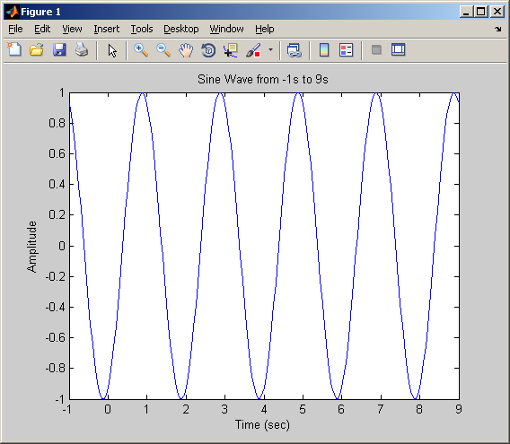

f_3 =

2

f_4 =

3

f_5 =

5

f_10 =

55

f_20 =

6765

v_3 =

1 0 1 0 1 0

v_1 =

1 0

v_2 =

1 0 1 0

v_5 =

1 0 1 0 1 0 1 0 1 0

v_10 =

Columns 1 through 18

1 0 1 0 1 0 1 0 1 0 1 0 1 0 1 0 1 0

Columns 19 through 20

1 0

A =

8.6869 4.3141 1.3607 8.5303 0.7597
0.8444 9.1065 8.6929 6.2206 2.3992
3.9978 1.8185 5.7970 3.5095 1.2332
2.5987 2.6380 5.4986 5.1325 1.8391
8.0007 1.4554 1.4495 4.0181 2.3995

I =

1 0 0 0 0
0 1 0 0 0
0 0 1 0 0
0 0 0 1 0
0 0 0 0 1

one_indices =

1
7
13
19
25

B =

1.0000 4.3141 1.3607 8.5303 0.7597
0.8444 1.0000 8.6929 6.2206 2.3992
3.9978 1.8185 1.0000 3.5095 1.2332
2.5987 2.6380 5.4986 1.0000 1.8391
8.0007 1.4554 1.4495 4.0181 1.0000

